1270

Over Parish Council
7.30pm Minutes Full Council Meeting
Over Parish Council Meeting, the Conservatory, Over Community Centre, Over - Tuesday 10th December 2019

PRESENT
Chairman: Mr G Fenn
Vice Chairman: Mr G Twiss
Councillors: Mr A Mills, Mrs J Davies, Mr S Couper, Mrs H Pletts, Mr R Robinson, Mrs A Griffiths, Mr M Conlon
Parish Clerk: Mrs M Pink
In attendance
County Councillor: None
District Councillor: District Cllr B Handley
Parishioners: None

Item
2019/12-01 To Receive and Accept Apologies for Absence
Cllr M Hyde, Cllr A Tranter, County Cllr P Hudson, District Cllr D Percival

2019/12-02 Members’ Declarations of Interest & Dispensations
2.1 Declarations of interest from councillors on items on the agenda – Registered Interests received from
Cllr S Couper – Trustee of Over Day Centre
Cllrs R Robinson, J Davies, A Griffiths – Trustees of Over Town Lands Charity
Cllr A Griffiths – Trustee of Over Community Association
2.2 Requests to Speak - No requests received to speak on any items as declared above.
2.3 To receive requests for dispensations - No requests received.
2.4 To grant requests received - The granting of dispensations to be made by Full Council.

2019/12-03 Meeting suspended to allow 15 minutes for the public participation forum and for persons declaring prejudicial interest relating to business to be transacted, to address the meeting.
No Parishioners present

2019/12-04 To Sign & Approve Minutes of the Full Parish Council Meeting Dated 12th November 2019
RESOLVED: It was proposed, seconded and unanimously approved that the Chairman signs the Minutes
of the above meeting with no amendments. All actions have been completed.

2019/12-05 Matters of Interest from County and District Councillors and PCSO
5.1 County Council – Written report from Cllr P Hudson circulated prior to the meeting. Noted
5.2 District Council – Written report from Cllr Handley circulated prior to the meeting. Noted
5.3 Police – No report

2019/12-06 Planning – For Discussion and Approval
6.1 Application – S/3930/19/RM– Unit 7, Chain Farm, Overcote Rd – Approval of reserved matters for access, appearance, landscaping, layout and scale – open sided agricultural building
RESOLVED: It was proposed, seconded and unanimously approved that the Council comment is no objections.
6.2 Application – S/3946/19/RM– Unit 1, Chain Farm, Overcote Rd – Approval of reserved matters for access, appearance, landscaping, layout and scale – open sided agricultural building
RESOLVED: It was proposed, seconded and unanimously approved that the Council comment is no objections.
6.3 Application - S/3948/19/RM– Unit 5B, Chain Farm, Overcote Rd – Approval of reserved matters for access, appearance, landscaping, layout and scale – open sided agricultural building
RESOLVED: It was proposed, seconded and unanimously approved that the Council comment is no objections.

1271

6.4 Application - S/3965/19/RM– Unit 3, Chain Farm, Overcote Rd – Approval of reserved matters for access, appearance, landscaping, layout and scale – open sided agricultural building
RESOLVED: It was proposed, seconded and unanimously approved that the Council comment is no objections.
6.5 Application - S/3945/19/RM– Unit 4, Chain Farm, Overcote Rd – Approval of reserved matters for access, appearance, landscaping, layout and scale – open sided agricultural building
RESOLVED: It was proposed, seconded and unanimously approved that the Council comment is no objections.
6.6 Application - S/3953/19/RM– Unit 6, Chain Farm, Overcote Rd – Approval of reserved matters for access, appearance, landscaping, layout and scale – open sided agricultural building
RESOLVED: It was proposed, seconded and unanimously approved that the Council comment is no objections.
6.7 Application - S/3975/19/FL – 16 Willingham Road – First storey extension and roof alterations
RESOLVED: It was proposed, seconded and unanimously approved that the Council comment is no objections.
6.8 Application - S/4015/19/FL – 31 Chapmans Way – Two storey rear and single storey side extensions
RESOLVED: It was proposed, seconded and approved five to two that the Council reject this application as the site is being over developed and is almost up to the boundaries and will overlook and overshadow the other residences. It is also not in keeping with the other houses in the area and will therefore impact on the current street scene.
Consultations for Discussion and Comments
6.9 Consultation – Cambridge and Peterborough Minerals and Waste Local Plan – Proposed Submission Plan – noted by Council
6.10 Consultation – Cambridge County Council Climate Change and Environment Strategy and Action Plan – moved to January for more information.

2019/12-07 VILLAGE MATTERS
7.1 To receive Village Handyman Report and consider any maintenance items – Report noted
7.2 Timebank update –The Clerk and Cllr Couper met with the Swavesey Group on the 19th November and Cllr Couper gave a brief presentation to the Council. The Clerk had also provided a written report of the main points to consider. Swavesey PC are very keen to work together. A cost of between 2-4K could be added to the budget. Cllr Mills asked the Council if they would be happy to go ahead now and begin the employment process so that the new co-ordinator could carry out the consultation and set up the scheme. The Clerk is to talk to Swavesey to see if they want to start working on this now rather than waiting for a full consultation process. This will be reviewed again in January. ACTION CLERK
7.3 Hedgerow and pathway maintenance in the Village – The Clerk has provided more information regarding the location of the actual paths/bridleways etc. and the Council have decided to let County Council cut as per their schedule and the Parish Council will pick up any items that need attending to in between the County Council maintenance.
7.4 Pavilion refurbishment – Quotes to consider – The Handyman has sourced a guide quotation to provide a new hot water system in the Pavilion and the Council will need to receive two others before they can action the work but have agreed that the work stated is needed. The quotation for works to the loft hatch to facilitate the new hot water system is to be actioned now. ACTION Clerk & DB
7.5 Mobile Warden Scheme to be discussed – Cllr Couper reported that a mobile warden scheme can be run independently or with the aid of Age UK. South Cambridgeshire District Council are offering grants to cover the first two years of funding. A potential cost for this type of scheme could be approximately £12,000pa. The Clerk is to talk to Lesley McFarlane about funding and can apply for funding if needed.
RESOLVED: It was agreed that the Clerk can apply for funding once she has received more information about Age UK Schemes from Lesley McFarlane. ACTION CLERK
7.6 Swift Boxes to be discussed – Cllr Pletts has received the application form for funding and will complete it and submit it to the District Council for consideration. ACTION HP
7.7 Happy to Chat Bench request to be discussed – Cllr Couper had provided the Council with a sample sign that can be attached to the benches in the Village inviting people to sit and chat at certain benches in an initiative to promote more Community Involvement. The Council agreed that they would not take up this initiative as people can choose to chat if they want to without a sign inviting them to do so.
1272

7.8 Conker Tree – Request to plant on the Green – Cllr Tranter is investigating village enhancements and he may well be able to find a place for a Conker Tree within his different projects. The Green is not a good place for a Conker Tree. The Clerk is to let the resident know and to ask Cllr Tranter to think about incorporating this tree into his planting schemes within the Village ACTION CLERK & AT
7.9 Cambridge & Peterborough Against Scams Partnership – Ways to help – The Clerk asked the Council to consider supporting this initiative where they possibly can as Scams are becoming very prevalent within the Community and any action to stop them is welcomed.
RESOLVED: It was agreed that the Council will support this initiative where possible.
7.10 Community Governance for Northstowe update following joint villages meeting – The Clerk had provided a report for the Council which was noted
2019/12-08 PC REPRESENTATIVES ON VILLAGE CHARITIES AND OTHER BODIES - MATTERS OF INTEREST
8.1 Hanson Aggregates – No report
8.2 Over Town Lands Charity – No report
8.3 Over Community Association – Cllr Griffiths reported that the fireworks event had been successful, and a letter had been received thanking the Council for their donation. Bar takings were reported as being on target for an event and feedback was good. The Pensioners dinner was a success. The Centre is also looking to recruit more staff at the present time.
8.4 Over Day Centre – Cllr Couper reported that Over people were well represented at the Centre but there were still some places available. Workshops had been held to talk about the services on offer and there is to be a further session focusing on Dementia. The Centre helps people that are lonely and those that suffer from Dementia and further marketing will be investigated.
2019/12-09 FEEDBACK FROM AD HOC GROUPS
9.1 Grant seeking – Cllr Mills reported that the Skate Park group had held another successful meeting that focused on the set up of the Group and ways in which they could look for funding. (The Clerk will add Skate Park reports into section 8 for further meetings.) The Group would ideally like to enlarge the current area if possible and the Chairman stated that they would need to talk to the Centre about this rather than the Parish Council. The Group is looking for ways to carry out consultation and will look to the School and also Village Groups like the Scouts. The Skaters are all being very positive and are sharing ideas with the Group. Funds at the moment are not forthcoming as events will need to be held to provide funds to carry the group forward but the Council discussed ways in which it can help at the start-up of the Group and it was suggested that the Group can apply to the Council for a grant of £500 to give them a kick start for the project.
RESOLVED: It was proposed, seconded and unanimously approved that the Clerk should send a Grant Application form to the Group for completion. ACTION CLERK
The Chairman reported that Cllr Tranter had provided a grant analysis for the Overcote Project which highlighted a shortfall of approximately £50,000 to provide repairs to roads. This will need to be looked at further before any decision can be made regarding this matter. The grant bids to FCC and Pocket Parks would need a third-party contribution of approximately £10,000.
9.2 Land Registry update – Cllr Twiss reported that he is still waiting for the County Council to carry out a survey of the Gravel. The agreement with the Homeowner at Church End Pond is now OK and the Council could still possibly obtain possessory title to the Pond. An email received on the 10th December from the Land Registry apologised for the delay and stated that they are now processing the consolatory payment which will be paid online.
9.3 Refurbishment of Church End Seats update – The Clerk contacted the Highways Department and they have agreed to provide a concrete slab to sit the seats on once refurbishment has been carried out. Cllr Robinson has asked Dennis Vacher (from CC) if they can provide a slab larger than the seat area so that vehicles do not drive over it and people will have a place to put their feet. The Highways Department will visit site to see if this will be possible. Cllr Robinson will therefore keep the benches in situ until he hears further from the County Council. ACTION RR
9.4 Speed Watch update – Cllr Conlon reported that a vehicle had been recorded three times now and a letter will be delivered by the Police. Speed Watch sessions will now cease until the better weather in the Spring.

1273

Parish Council meeting suspended in order to discuss items relating to the Registered Charity for The Green (Charity number: 300418) Parish Council is Sole Trustee of the Charity
2019/12-10 THE GREEN
10.1 To review the report from the Grounds Man –Report noted – The Chairman reported that the Colts have moved some games to the Centre and OCA may possibly ask the Parish Council to look at drainage. The Football Clubs have asked the Groundsman to carry out some work at the Centre to see if he can improve the playing surface.
Parish Council meeting reconvened
The trustees of the Charity asked the Clerk to action any items as above

2019/12-11 Procedures
11.1 New Councillor Training date to be arranged – The Clerk has received a quote for bespoke training at £700 per session or a possible £150 per candidate from CAPALC.
RESOLVED: It was agreed that the Clerk will look at this again in the New Year when the Council re-join CAPALC as the costs will be cheaper.

2019/12-12 FINANCE
12.1 Approval of Payments
RESOLVED: To approve invoices and payments as listed to the sum of £4,087.57
12.2 Receipts noted: As below
12.3 Budget and Precept to be decided – This will be actioned in January
12.4 Donation Request for The Bobby Scheme to be discussed – No donation to be provided as national scheme and not Village focused.
12.5 Donation request for the Thrive Café – Ely Diocese to be discussed – Cllr Couper reported that there had not been a request for a donation but an actual request to see if Over would benefit from the Youth Café. The Clerk is to find out some further information. ACTION CLERK
12.6 Donation request from the British Legion for support with the VE Day planned event – The Clerk has received an email from the Over & District RBL Chairman regarding the planned VE Day event in April. A band had been commissioned to play and the cost was £600.
RESOLVED: It was proposed, seconded and unanimously agreed that the Council should provide a donation using LGA 1972 Section 137 for £300

2019/12-13 GENERAL CORRESPONDENCE – Correspondence had been received from OCA thanking the Council for their donation towards the Fireworks Display, The Poppy Appeal had also thanked the Council for their donation for wreaths for Remembrance Day. Correspondence had also been received from the PCC regarding an invitation to the Council to attend a Carol Service on the 22nd December.
Planning correspondence had also been received for a Discharge of Conditions for application ref S/4127/19/DC – 2, West Street which was noted by the Council and also for a Variation of Conditions for Application Ref S/4171/19/VC – Land West of Mill and the Clerk is to ask for an extension for comments so that this application can be discussed by the Council. ACTION CLERK
2019/12-14 ITEMS FOR INFORMATION AND REQUESTS FOR AGENDA ITEMS FOR FUTURE MEETINGS
Items from this meeting to be carried forward –Swift boxes grant, Mobile Warden survey, Precept and Budget, Pavilion refurbishment, Conker Tree, New Councillor Training, Cambridge County Council Climate Change and Environment Strategy and Action Plan and Time banking
(Skate Park Report to be added to section 8 PC Reps.)

1274
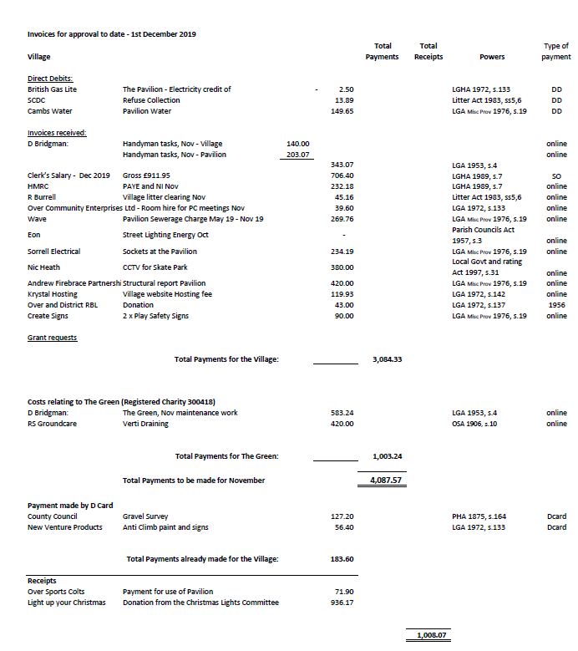

Next meeting dates:
Full Council – 7.30pm Tuesday 14th January 2020, The Seminar Room, Over Community Centre
There being no further business, the meeting was declared closed at 9.58PM

Signed & dated Chairman

