1316
Over Parish Council
7.30pm Minutes Full Council E-Meeting – Tuesday 10th November 2020
PRESENT
Chairman: Mrs A Griffiths
Vice Chairman: Mr G Twiss
Councillors: Mr A Tranter, Mrs M Hyde, Mrs J Davies, Mr S Couper, Mrs H Pletts, Mr R Robinson, Mr M Conlon (2 Vacancies)
Parish Clerk: Mrs M Pink
In attendance
County Councillor: None
District Councillor: Mr B Handley
Parishioners: 0
Item
2020/11-01 To Receive and Accept Apologies for Absence
County Cllr P Hudson, District Cllr D Percival
2020/11-02 Members’ Declarations of Interest & Dispensations
2.1 Declarations of interest from councillors on items on the agenda – Registered Interests received from
Cllr S Couper, Cllr A Tranter – Trustee of Over Day Centre
Cllrs R Robinson, M Hyde, A Griffiths – Trustees of Over Town Lands Charity
Cllr J Davies – Trustee of Over Community Association
Cllr Griffiths declared an interest in Agenda Item 5.3
2.2 Requests to Speak - No requests received to speak on any items as declared above.
2.3 To receive requests for dispensations - No requests received.
2.4 To grant requests received - The granting of dispensations to be made by Full Council.

2020/11-03 Public Participation – None

2020/11-04 Minutes
4.1 To Approve Minutes of the Full Parish Council Meeting Dated 13th October 2020
RESOLVED: It was proposed, seconded, and unanimously agreed that the Minutes are approved. The Chairman will sign the Minutes at the next available Full Council Meeting. All actions have been completed. ACTION CHAIR
2020/11-05 Planning – For Discussion and Approval
5.1 Application – 20/04118/HFUL - 1 Fen End - Two storey side extension and front door alteration
RESOLVED: It was proposed, seconded, and unanimously approved that the Council comments are noted as no objections
5.2 Application – 20/04164/HFUL – 17 Giffords Way - Single storey rear extension
RESOLVED: It was proposed, seconded, and unanimously approved that the Council comments are noted as no objections
5.3 Application – 20/04162/HFUL – 11 The Lanes - Demolition of single storey side extension and porch. Construct new single storey side/rear extension & porch
RESOLVED: It was proposed, seconded, and unanimously approved that the Council comments are noted as no objections
5.4 Application – 20/04080/FUL – Land Adjacent 167 Station Road Willingham - Proposed detached chalet bungalow and garage - This application is in Willingham and not Over
Planning for Information Only
5.5 Application – 20/04285/S73 – 30 Unwins Lane - Variation of condition 2 (approved plans) pursuant to planning permission 20/02269/HFUL (Single storey extension)
5.6 Application – 20/2136/TTCA – 53 High Street – Tree work - Various
5.7 Application – S/1876/17NMA1 – 15 Station Road - Non material amendment on application S/1876/17/FL for replacement of bi-fold doors to windows in ground floor bedroom, alteration to back exterior wall, addition of exterior door to utility room, replacement of existing window next to stairs with front door, removal of front door in snug, addition of door to master bedroom at top of new stairs and removal of staircase in snug
1317
2020/11-06 Finance
6.1 Approval of Payments – The Clerk asked if a payment of £396.00 to The Fire Authority can be made now and then added to the payments list for November.
RESOLVED: To approve invoices and payments as listed to the sum of £7,475.92 and to make the payment noted above.
6.2 Receipts noted: Total received £75.00
6.3 External Audit Report to be noted – No actions to take – Noted by Council
6.4 Covid-19 support grant applied for – to be noted (action needed before the 22nd Oct) – The Clerk informed the Council that SCDC had announced that a new support grant for emergency funds to be used by Village Support Groups could be applied for but a decision was needed by the 22nd October. The amount is determined by the number of the electorate. It is believed that the amount will be around £300. The Clerk confirmed with both the Chairman and Vice Chairman that they were happy for the grant to be applied for. The Council will hold the grant on behalf of the Village Support Group. Cllr Handley confirmed this and gave a few more details to the Council to help them with their understanding of the grant. A further grant can also be applied for by individual residents in need and can be applied for via the support group or directly to SCDC. He will forward more information to the Clerk. ACTION Cllr Handley
2020/11-07 Employment
7.1 Clerks Appraisal to be discussed – The Chairman had provided an email report on the 9th November to the Council following the Appraisal meeting held on Tuesday 20th October. The recommendations in the Employment Team report formed the proposal put forward to the Council for approval. As, due to the pandemic, this appraisal was 6 months overdue the next appraisal will be in March/April 2021. For clarity, we will define the Clerk’s contracted hours as 87 per month (approximating to 20 hours per week) and the Clerk’s monthly salary will be calculated on that basis going forward at SCP24.
RESOLVED: It was proposed, seconded, and unanimously approved that the Council approves the recommendations for employment made by the Employment Team.
2020/11-08 Village Matters
8.1 Covid 19 Snake – Quotation for installation to be discussed – The Clerk had provided rough dimensions and weight of the snake to Cllr Hyde but she was not able to get a firm quotation as more in depth information is needed. Cllr Twiss highlighted a different location for the installation of the snake. Placing the snake at ground level along the base of the wall outside the Church was discussed and the Clerk is to investigate this option. ACTION CLERK
8.2 Pavilion – Decision needed re electrical testing and changes to lights at the Pavilion – The Clerk had asked Cllr Robinson to get new quotes for the 5-year electrical testing in the Pavilion. It was decided however that as PAT testing was also needed that this would be carried out at the same time at an approximate cost of £200. Cllr Robinson will provide the Clerk with the invoice for payment and the electrical testing certificates. The Clerk is to officially issue a Purchase Order for works to the Pavilion to the Contractor so that the work can be booked in for action. Payment of the invoice is to be made now and then added to the payments list in November. ACTION CLERK
8.3 Church End Seat – Quotation for white lining in front of the seat to be discussed – The Clerk has asked the County Council to provide a quote for white lining and the words “keep clear” to be placed in front of the seat area to stop parking/stopping in front of the seat. She has chased for the quote but has not received it yet. ACTION CLERK
8.4 Protection of Overcote from illegal encampments to be discussed – The Clerk asked the Council to suggest some possible solutions to the problem of illegal encampments at Overcote. This matter was discussed at length and it was determined that removal of illegal encampments can be a long process that can be costly, however putting a physical restriction at an open village area is not an option. This will hamper the free movement of users of the facility as well as farmers who graze their livestock in and around the riverbank. Cllr Handley was asked if the District Council could help with this matter and he provided some further details regarding procedure etc. The Clerk is to try and find out if there are any specialist consultancy companies who can help with this matter. Byelaws are to be looked into and the Clerk will also ask CAPALC for any advice. The Clerk is to also find out if there are any insurance policies that can be taken out to help with costs. ACTION CLERK

1318
8.5 Highway Meeting update to be noted – The Clerk had provided details of the latest County Council Highways Meeting – Update noted by the Council
8.6 OCA request for support from reserved funds – Quotations to be considered. The Over Community
Association have requested financial support to enable them to make changes to the entrance doors
at the centre.
RESOLVED: It was proposed, seconded, and unanimously approved that the Council provides a donation equal to the lowest quotation supplied. The VAT element is not to be included in the donation. The Clerk will send OCA a grant request form. ACTION CLERK
Cllr Handley left the meeting at 8.30pm
8.7 HGV Covenant proposal to be discussed – Cllrs discussed and proposed that a letter be sent to local haulage companies promoting the County Council HGV Covenant Scheme and the use of the local advisory freight maps to help to alleviate some heavy goods traffic travelling through Over Village. It was suggested that a small trial is to be initiated to see what response is received.
RESOLVED: It was proposed, seconded, and approved that Cllr Pletts works with the Clerk to see what can be achieved. ACTION CLERK & HP
8.8 Final confirmation of lamp posts to be used for speed sign installation – list to be confirmed so that the Clerk can apply for a permit. Suggestions have been made by Cllrs Twiss and Couper for locations for the speed sign within the Village. The Chairman will have a final walk about to determine which lamp posts can be used. ACTION CHAIR, CLERK
Parish Council meeting suspended to discuss items relating to the Registered Charity for The Green (Charity number: 300418) Parish Council is Sole Trustee of the Charity
2020/11-09 The Green as a Charity Information & approval
9.1 Request by the Football Club for the Installation of socketed goals on the Green to be discussed A request has been received for permission to install socketed goals on the Green for the use of the Over Colts. A report from the Colts was provided for the Council to consider. Roll Out goals are not to be considered for the Green as per the decision made in October. Therefore, the solutions to consider are socketed goals or the continued use of the original goalposts. RESOLVED: It was proposed, seconded, and unanimously approved that the Council supports the use of socketed goals at the Green. They must be capped when not in use and removed after every game. The installation needs to be supervised by the Groundsman and consideration will have to be given to the underground drainage channels ACTION CLERK & DB
Parish Council meeting reconvened

2020/11-10 Matters of Interest from County and District Councillors and PCSO
10.1 County Council – Emailed report from Cllr P Hudson circulated prior to the meeting. Noted
10.2 District Council – Emailed report from Cllr B Handley circulated prior to the meeting. Noted.
10.3 Police – None
2020/11-11 Village Reports
11.1 To receive Village Handyman Report and consider any maintenance items – Report noted
11.2 To receive Groundsman Report re the Green – Report noted
2020/11-12 PC representatives on Village Charities and other bodies – Matters of interest Information
12.1 Hanson Aggregates – No Report
12.2 Over Town Lands Charity – SCDC have not approved the change of use category for the Town Hall due to
lack of parking. New address details are to be provided to the Land Registry for land owned by the Charity.
12.3 Over Community Association – The AGM was held, and new Officers have been appointed.
12.4 Over Day Centre – Letter to be noted giving thanks to the Council for the grant. Re-opening plans have
been delayed but the clients are all very keen to come back.
12.5 Community Warden – The Clerk and Cllr Hyde are to join the steering group to ensure the smooth
running of the new Community Warden Scheme in the Village.
12.6 Speed Watch – One session was held in October and two others were rained off. All sessions have now
been stopped due to the current Covid-19 restrictions

1319
The Clerk received a last-minute email from the RBL requesting permission to remove the current bench at the memorial site and to replace it with a new version. This request arrived too late to be an official agenda item in November but will be discussed officially in December. However, as the bench is to be fully funded by other means and it is only permission being asked for at this time a response, in principle, will be made to state that the Parish Council are happy to have the old bench replaced but would welcome a bench design that reflects peace and remembrance rather than promoting armaments so a final decision will be given when the final design of the bench has been supplied. The Clerk is to ask for a final design so that this can be discussed officially in December.

The Christmas Lights are currently being installed and the tree will be delivered soon

The Chairman and the Clerk have issued a new Councillor Vacancy Notice that is to be promoted within the Village via the notice board, website, and Facebook. All applications are to be received by the 4th January so that a decision can be made at the Co-Option Meeting in January.

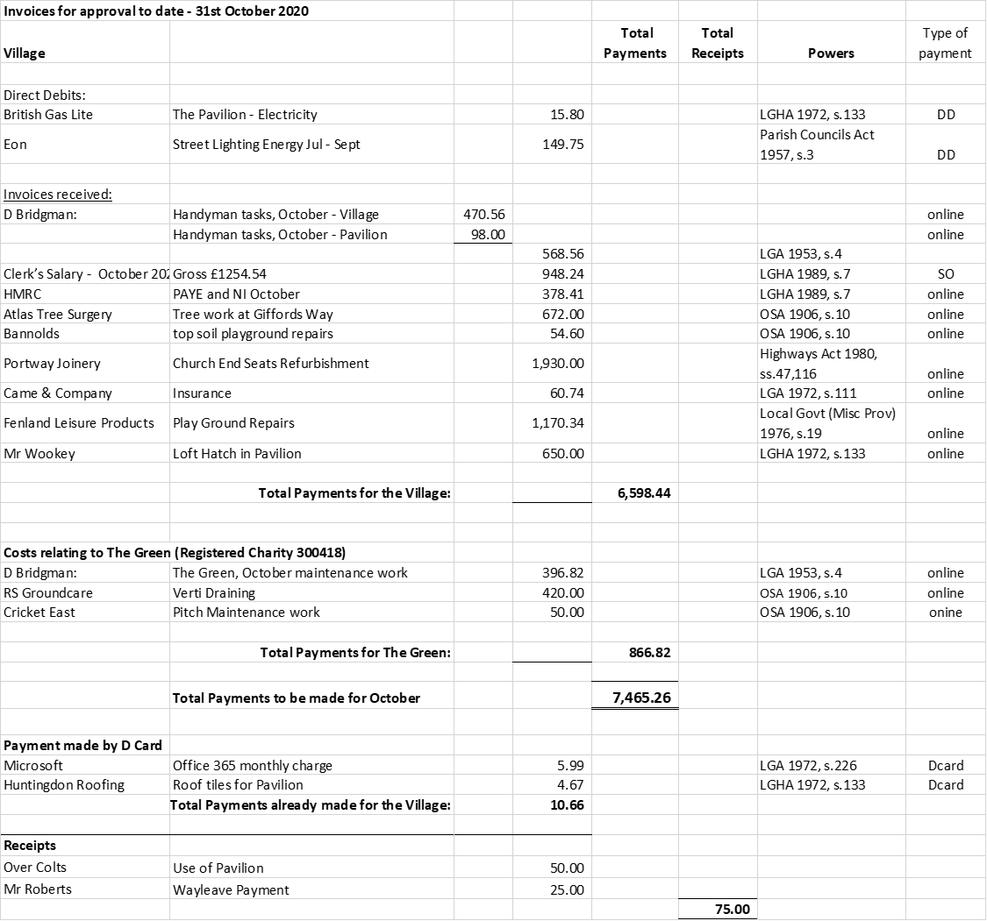
Next meeting dates: Full Council E-Meeting – 7.30pm Tuesday 8th December 2020
There being no further business, the meeting was declared closed at 9.28PM
These minutes are unadopted
Signed & dated Chairman

