1345
Over Parish Council
7.30pm Minutes Full Council Informal E-Meeting – Tuesday 8th June 2021

This meeting of the Parish Council is an informal meeting and as such any decisions made at this meeting will be made now, in principle, and will be ratified at the next formal meeting.

PRESENT
Chairman: Mrs A Griffiths
Vice Chairman: Mr G Twiss
Councillors: Mrs J Davies, Mr S Couper, Mr M Conlon, Mr R Robinson, Mr A Tranter, Mrs M Hyde
(3 Vacancies)
Parish Clerk: Mrs M Pink
In attendance
District Councillor: Mr B Handley
County Councillor: Ms F Thompson
Parishioners: 3

2021/06-01 To Receive and Accept Apologies for Absence
District Cllr D Percival
2021/06-02 Members’ Declarations of Interest & Dispensations
2.1 Declarations of interest from councillors on items on the agenda – Registered Interests received from
Cllr A Tranter – Trustee of Over Day Centre
Cllrs A Griffiths, R Robinson – Trustees of Over Relief in Need, and The Church and Town Lands Charity, Church and Town Branches
Cllr J Davies – Trustee of Over Community Association
2.2 Requests to Speak - No requests received to speak on any items as declared above.
2.3 To receive requests for dispensations - No requests received.
2.4 To grant requests received - The granting of dispensations to be made by Full Council.
2021/06-03 Matters of Interest from County and District Councillors and PCSO
3.1 County Council – Report noted - Cllr Thompson highlighted her report for items of interest to the Council.
3.2 District Council – Report noted – Cllr Handley reported that the zero-carbon community grant may be a good funding pot for the Day Centre.
3.3 Police – No report.

2021/06-04 Public Participation – Three members of OSKA gave a presentation to the Council to provide an update on the current skate park proposals. They thanked the Council for giving support to the project. Groundwork have completed the consultation and will now generate a design brief as part of the tender pack. The next phase of the project is to raise money for this stage. Approximately £2,500 +VAT is needed. Bid funding is now being investigated and applications have been made to both Tesco and the Co-op Community Funds. The Council thanked OSKA for their work so far and look forward to seeing the designs when they are available.

2021/06-05 Minutes
5.1 To Approve Minutes of the Informal Full Parish Council Meeting Dated 11th May 2021
Cllr Couper asked for some changes to be made to the opening statement on the May Minutes. The first sentence should finish with the words “to be ratified at the next formal meeting”.
RESOLVED: It was proposed, seconded, and unanimously agreed that the Minutes are approved following the changes noted above. The Chairman will sign the Minutes at the next available Full Council Meeting. All actions have been completed. ACTION CHAIR
2021/06-06 Planning – For Discussion and Approval
Cllr Couper declared that he would not participate in the planning agenda item and would abstain from all decisions made
6.1 Application – 20/05343/FUL - 1 Drings Close - Extension of existing Doctors' Surgery to provide new consulting rooms, toilets and office space, vehicular access relocated to suit new extension and car park re-arranged to create additional parking spaces – Discussed in May.
1346
6.2 Application – 21/01636/HFUL- 75 Willingham Road - Extensions to the front and rear, to raise roof and incorporate more bedrooms at first floor.
RESOLVED: It was proposed, seconded, and agreed seven for with one abstention that the Council comments are noted as no objections.
6.3 Application – 21/01709/FUL – Duces Pond – Re-profiling and enlargement of existing pond
RESOLVED: It was proposed, seconded, and agreed seven for with one abstention that the Council comments are noted as no objections. Cllr Tranter suggested that a bench could be provided once the improvements have been made. The Chairman asked the Clerk to add this to the budget proposals for the next financial year. ACTION CLERK
6.4 Application - 21/02043/HFUL – 13 Chapmans Way - Single storey rear extension
RESOLVED: It was proposed, seconded, and agreed seven for with one abstention that the Council comments are noted as no objections.
Cllr Thompson left the meeting at 8.07pm
6.5 Application - 21/02048/CL2PD - Charter Cottage Horse Ware - Certificate of lawfulness under Section 192 for the demolition of existing barn and clearance, levelling, and removal of excess soil from the site, the creation of an access and driveway and the setting out of the footprint of the building in accordance with the approved Planning Permission ref S/1883/18/FL.
RESOLVED: It was proposed, seconded, and agreed seven for with one abstention that the Council comments are noted as no objections. Cllr Twiss reported that this application is just needed for information as the work has already been carried out.
Planning for Information Only or Comments if needed.
6.6 Application - 20/02477/CONDB -Land off Fen End - Submission of details required by condition 22 (Piling Mitigation) of permission 20/02477/FUL.
Cllr Twiss informed the Council that the piling works are needed due to the number of ponds in this area and the Council did point this out to the planning department when this application was first discussed. There may also be rising gases in this area so ventilation may also be needed. Cllr Handley informed the Council that the piling is non percussive piling, and it will not damage the area.
6.7 Application – 20/02477/CONDC – Land off Fen End - Submission of details required by conditions 5 (Biodiversity) and 11 (Energy Statement) of permission 20/02477/FUL - Noted
6.8 Application – 21/0589/TTCA – 20 High Street – Tree works – Removal of dead tree - Noted
6.9 Application – 21/0653/TTCA – 20 High Street - Tree works – Various - Noted
6.10 Application - 21/0641/TTCA – The Vicarage – Tree works – Various - Noted
6.11 Application – 21/0669/TTCA – The Vicarage – Tree works – Fell Sycamore tree - Noted
2021/06-07 Finance
7.1 Approval of Payments
RESOLVED: To approve invoices and payments to the sum of £9,814.04
7.2 Receipts noted: £1,799.01 (VAT Refund)
7.3 Green Charity Accounts 2020 - 2021 to be noted – Noted by Council – The Clerk informed the Council that a Charity Meeting will need to be set so that a top up donation could be made, and a new bank account confirmed.
2021/06-08 Procedure Information & Approval
8.1 Internal Audit Report to be noted – Not yet received by the Clerk.
8.2 New Model Code of Conduct to be adopted if agreed – The Clerk informed the Council that a New Model Code had been approved by both the Local Government Association and the National Association of Local Councils, but it was not yet known if it would also be adopted by the District Council. More information should be released shortly, and it would be prudent to wait to discuss adoption of the Code until further information has been received. ACTION CLERK
2021/06-09 Village Matters Information & Approval
9.1 Asplins Close parking area update – No new update
9.2 Protection of Overcote from Illegal Encampments update – The Clerk has completed the online training and links have been sent to the Chairman and Cllr Hyde. The Toolkit has not yet been released for action to be taken.
9.3 Update details from the meeting with Manderson Trust re possible toilet facilities at Overcote – The Clerk had organised a meeting with the Trust and Cllrs Twiss, Tranter and Couper and this meeting was
1347
positive, and it is hoped that the Trust and the Council can work on this project together. Cllr Tranter gave a brief outline of what was discussed, and the meeting notes had been circulated by the Clerk. The Trust have provided some concept drawings and the Council will now look into getting some costings for the project. Cllr Twiss thought that a trial run with some temporary portable toilets could give an indication of likely use and this option should be explored before any permanent arrangements are identified. Cllr Tranter will liaise with the Trust and will also get some costings together for further discussion and the Clerk will organise some quotes for temporary facilities so that this can also be discussed. ACTION CLERK & AT
Cllr Handley left the meeting at 8.15pm
9.4 20’s plenty campaign for support for a 20mph limit in rural villages to be discussed – The Clerk advised the Council that this is something that the whole Village should be consulted on before a decision can be made and it is hoped that this can be discussed at the next Parish Meeting which will be organised when the Covid restrictions have been lifted. ACTION CLERK
2021/06-10 Village Reports
10.1 To receive Village Handyman Report and consider any maintenance items – No report
10.2 To receive Groundsman Report re the Green – No report
2021/06-11 PC representatives on Village Charities and other bodies – Matters of interest Information
11.1 Hanson Aggregates – Cllr Twiss advised the Council that he had received an email from Hansons regarding some test boring in certain other areas of and around the existing site. These pieces of land belong to the Over Relief in Need, and The Church and Town Lands Charity, Church and Town Branches and Mrs Henshaw will be contacting them about this. Cllr Twiss wanted to make the Council aware that if the test bores are successful then Hansons may want to acquire the land, and this would then leave the Council owned land referred to as the Gravel and Gravel Tree Belt surrounded by Quarry and no longer useable or needed. Cllr Tranter also advised the Council that he had received some communication from Helen Wass, County Council Officer, regarding reinstatement of footpaths if they are taken over by the Quarry works.
11.2 Over Relief in Need, and The Church and Town Lands Charity, Church and Town Branches – No report
11.3 Over Community Association – Cllr Davies reported that the Vaccination programme is now finished at the Centre. The Café is doing well, and the Centre are looking into providing some bicycle racks.
11.4 Over Day Centre – Cllr Tranter reported that the Day Centre is open for two days per week, but this is likely to increase as 15 new assessments are under way to welcome some new clients to the Day Centre.
11.5 Community Warden – Update report emailed and noted by Council.
11.6 Speed Watch – Cllr Conlon reported that the first session has been completed and 152 vehicles were counted with the highest speed being recorded at 34mph on Willingham Road. The MVAS signs have now also been installed on some lamp posts in the Village and the sites of these signs will be varied so that a large area of the Village can be monitored. Cllr Conlon said that he had already received some good feedback about the use of the mobile signs.
2021/06-12 Correspondence received – The Clerk had forwarded an email received from a resident concerning dangerous driving at Overcote which was received on the 5^{th of} June, after the agenda had been posted. Cllr Twiss felt that some signage could be installed regarding a suggested speed and caution to be taken due to children. The Chairman asked the Clerk to prepare a cost proposal for this idea and to present it to the Council in July. ACTION CLERK

The Chairman asked each Councillor to confirm if they are now happy to meet face to face in July. The Clerk has provisionally booked the Main Hall in the Community Centre as this is larger than the Seminar room and social distancing will be a lot easier to maintain in a larger room. All Councillors agree that a return to face-to-face meetings can be arranged if the Government guidelines in force in July are followed. ACTION CLERK

1348

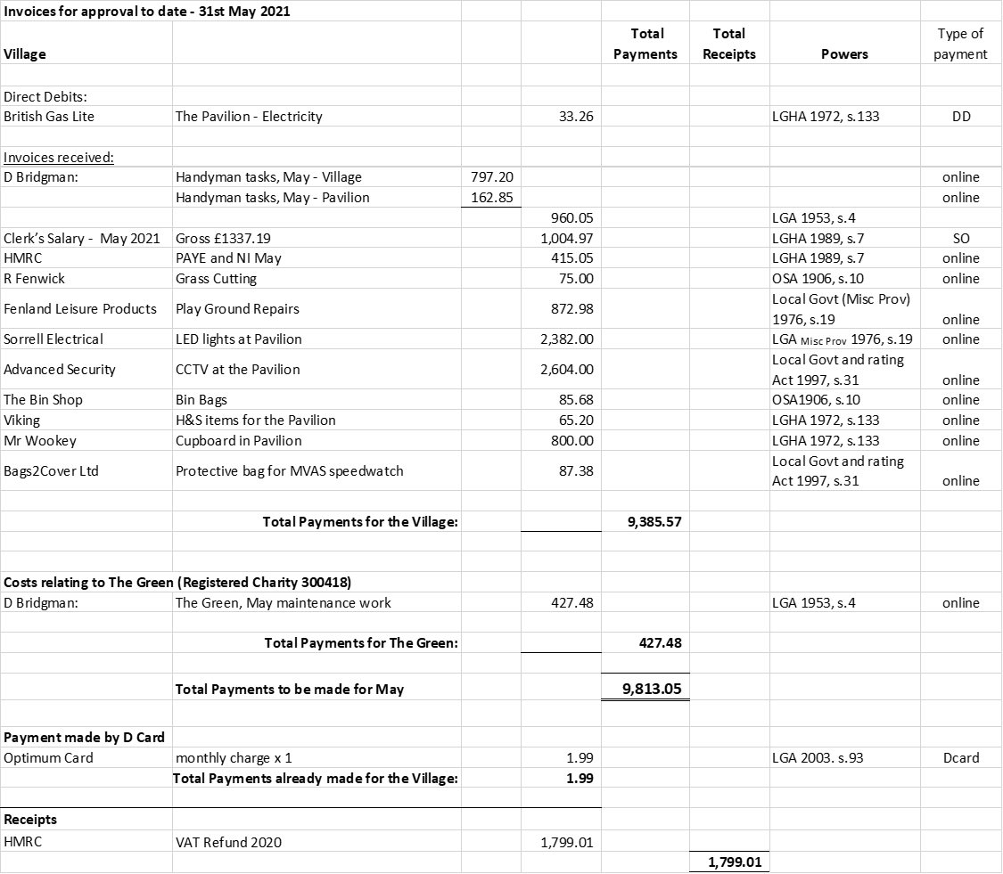

Next meeting dates: Full Council Meeting – 7.30pm Tuesday 13th July 2021
There being no further business, the meeting was declared closed at 9.11PM
Signed & dated Chairman.

