1332
Over Parish Council
7.30pm Minutes Full Council E-Meeting – Tuesday 9th March 2021
PRESENT
Chairman: Mrs A Griffiths
Vice Chairman: Mr G Twiss
Councillors: Mr A Tranter, Mrs J Davies, Mr S Couper, Mr M Conlon, Mr R Robinson (3 Vacancies)
Parish Clerk: Mrs M Pink
In attendance
County Councillor: None
District Councillor: Mr B Handley
Parishioners: 1
Item
2021/03-01 To Receive and Accept Apologies for Absence
County Cllr P Hudson, District Cllr D Percival, Cllr M Hyde
2021/03-02 Members’ Declarations of Interest & Dispensations
2.1 Declarations of interest from councillors on items on the agenda – Registered Interests received from
Cllr S Couper, Cllr A Tranter – Trustee of Over Day Centre
Cllrs A Griffiths, R Robinson – Trustees of Over Relief in Need, and The Church and Town Lands Charity, Church and Town Branches
Cllr J Davies – Trustee of Over Community Association
2.2 Requests to Speak - No requests received to speak on any items as declared above.
2.3 To receive requests for dispensations - No requests received.
2.4 To grant requests received - The granting of dispensations to be made by Full Council.

2021/03-03 Public Participation – Firouz Thompson introduced herself to the Council as a County Councillor candidate standing in the election on 6th May 2021. She was attending the meeting as an observer.

2021/03-04 Minutes
4.1 To Approve Minutes of the Full Parish Council Meeting Dated 9th February 2021
RESOLVED: It was proposed, seconded, and unanimously agreed that the Minutes are approved
The Chairman will sign the Minutes at the next available Full Council Meeting. All actions have been completed. ACTION CHAIR
Following a letter received from the Royal British Legion, that will be discussed at agenda item 2021/03-12, it was highlighted that the report made in the December minutes concerning funding for the proposed memorial bench was misleading. Full funding for the bench has been organised by the Royal British Legion and has been provided via a grant from South Cambs District Council and other independent fundraising events.
2021/03-05 Planning – For Discussion and Approval
5.1 Application – 20/01648/CONDB - 46 Station Road – Submission of details required by conditions 6 (Surface Water Drainage), 7 (LEMP), 8 (Hard and Soft Landscaping), 9 (Boundary Treatments), 10 (Materials), 11 (Foul Water Drainage), 12 (Street Management and Maintenance) and 13 (Carbon Emissions) of planning permission 20/01648/FUL
RESOLVED: It was proposed, seconded, and unanimously approved that the Council comments are noted as no objections
5.2 Application - 21/00516/HFUL - 3 Meadow Lane - Erection of a single garage and attached store RESOLVED: It was proposed, seconded, and unanimously approved that the Council comments are noted as objecting to the application. The Parish Council feel that the removal of the hedge is not in line with the adopted Over Village Design Statement principles which are to maintain hedges and trees within the Village. The removal of the hedge and subsequent installation of an intrusive brick wall will severely impact on the current street scene in this area of the Village. If the plans cannot be adapted to ensure that the hedge stays in situ, then some soft green planting should be made in front of the proposed garage to reinstate the green frontage.
Planning for Information Only
5.3 Application – 21/0203/TTCA – 18 High Street – Tree Works – Various trees reduction in height and width – noted by Council.
1333
5.4 Application – S/1876/17/NMA2 – 15 Station Road – Non-material amendment on permission S/1876/17/FL for the addition of 3 roof windows – noted by Council.
Consultation to be noted
5.5 Consultation on new housing policies relating to Build to Rent, Clustering and Distribution of Affordable Housing and Affordable Rent Setting – noted by Council.
2021/03-06 Finance
6.1 Approval of Payments
RESOLVED: To approve invoices and payments to the sum of £3,389.40
6.2 Receipts noted: none.
2021/03-07 Procedure
7.1 CAPALC Renewal to be agreed – The Council agreed that the renewal should be accepted but the increase in cost of 3% was high. Cllr Twiss reminded the Clerk to circulate the log in information for CAPALC and NALC so that all Councillors could access the members area for information and advice.
RESOLVED: It was proposed, seconded, and unanimously approved that renewal is actioned by the Clerk and log in details are circulated. ACTION CLERK
7.2 Data Protection Policy to be adopted – The Clerk tabled a policy to be agreed and the section regarding exporting of data is to be removed as the Council will never export data. The references to the EEA are also to be queried but the Clerk notified Council that the GDPR rules are an EU Directive that still needs to be followed even though the UK has now withdrawn from the EU. The Chairman asked the Clerk to review the Data Audit and to arrange a meeting for the Council specifically to determine the GDPR rules and regulations that they need to follow. The question of Cloud storage was also raised. The Policy is to be agreed as a working document that is subject to review following the meeting that is to be arranged.
RESOLVED: It was proposed, seconded, and unanimously approved that the Policy is adopted as a working document as per the points raised above. ACTION CLERK
7.3 Complaints Procedure to be adopted – The Clerk tabled a procedure to be agreed.
RESOLVED: It was proposed, seconded, and unanimously approved that the procedure tabled by the Clerk is adopted.
2021/03-08 Village Matters
8.1 Lighting to be changed to LED at the Pavilion to be discussed – The Clerk asked the Council to consider two quotations for the work stipulated. Option 1 at £1,985 + VAT and Option 2 at £1,875 + VAT RESOLVED: It was proposed, seconded, and unanimously approved that the Clerk should arrange for the work to be carried out using Option 1 as the contractor is known to the Council. Work is hoped to commence w.c 22nd March on the full refurbishment project at the Pavilion. ACTION CLERK
Cllr Handley left the meeting at 8.22pm
8.2 Asplins Close parking area update – The Clerk has not yet heard back from the Contractor, but she has been advised by the section 106 Officer that the first course of action is to apply for planning permission to change the use of the area from recreational to parking. Then the change to the covenant can be looked at if no word is received from the original Contractor as this will incur legal costs. The Council agreed that the Clerk can approach the District Council for some pre planning advice and she is to seek advice from CAPALC and NALC regarding the changes needed to the Covenant. ACTION CLERK
8.3 Protection of Overcote from Illegal Encampments – Proposal for action to be taken if agreed – The Clerk and Cllr Davies have assessed the items that can be actioned and tabled a proposal document for consideration. The document was discussed, and some format changes are to be made but the document covered what can be done before, during and after any possible incidents. The Council agreed that the Clerk and Cllr Davies can now work through the items raised in the proposal and further action can be taken when more information is available. ACTION CLERK & JD
8.4 Over Skate Park update - repairs needed for some equipment to be discussed – The Clerk asked the Council to consider repairs at the Skate Park as various pieces of equipment are now showing some signs of repair and need refurbishment work to be carried out. The Skate Park Group (OSKA) are now at consultation stage with their project and hope to be able to propose a new Skate Park in eighteen months or so. OSKA would ideally like to see the whole park in use until the new facilities can be organised but do understand that the Council must secure the site for health and safety reasons, but they are keen to work with the Council to ensure that the best interim remedial action is taken for the
1334
benefit or all. The Chairman asked the Clerk to circulate last year’s Safety Report and the repair quotation that was tabled in 2019 and to also move forward the annual Safety Report for the Skate Park so that the full extent of the safety issues can be identified. ACTION CLERK
8.5 OCA request for help with repairs to All Weather Surface Fencing at the Centre to be discussed – The Council agreed to look at helping to repair the fence at the Centre but would not replace it as it is a historic problem. Cllr Twiss provided the Council with some photographic evidence to show that the fence was damaged prior to the swing being installed. The Clerk is to arrange to put metal bird spikes on the top of the swing. It is thought that the addition of a metal bar along the top of the fence and the reattachment of the straining wire would repair the damage. The PC will consider releasing funds from the reserve to carry out the repair following the receipt of costings from OCA. ACTION CLERK
Cllr Conlon left the meeting at 9.33pm
2021/03-09 Matters of Interest from County and District Councillors and PCSO
9.1 County Council – Report noted
9.2 District Council – Report noted – There is a Gypsy Roma Traveller (GRT) training session on the 26/03
9.3 Police – No report
2021/03-10 Village Reports
10.1 To receive Village Handyman Report and consider any maintenance items – Report noted
10.2 To receive Groundsman Report re the Green – Report noted.
2021/03-11 PC representatives on Village Charities and other bodies – Matters of interest Information
11.1 Hanson Aggregates – The Chairman reported that the visitors centre accessed via the Willingham Road is nearing completion and will be fully opened later this year.
11.2 Over Relief in Need, and The Church and Town Lands Charity, Church and Town Branches – No report
11.3 Over Community Association – The Vaccination programme is running well. A problem with the heating system has been repaired and consideration is being made regarding a back up generator. The Centre will receive a tax refund and have also secured a £1000 grant which will all help with the day to day running costs of the Centre. Full depreciation is being levied on the building based on the term of the lease.
11.4 Over Day Centre – The Day Centre is still closed but it is hoped that it can reopen as soon as possible after restrictions have been lifted.
11.5 Community Warden – No report
11.6 Speed Watch – All sessions have been stopped due to the current Covid-19 Lockdown.
2021/03-12 Correspondence received - Letter received from the Royal British Legion asking for a response to a proposal regarding a new memorial bench. The full proposal was to be forwarded to the Council by the 1^{st of} March so that a response would be made by the 10^{th of} March, but the proposal has not been received. The Council asked the Clerk to request that the proposal is sent in time for consideration at the April meeting. For clarity, the proposal will need to be received before the 7^{th of} April.

Village Concerns raised after the meeting.
Councillor Helen Pletts has resigned her position as Councillor for Over PC and the Clerk is to write to thank her for her service. The Chairman has already issued an email.
Cllr Tranter reminded Cllr Twiss that the deadline for submission of articles for the Over News is the 15th of each month. An article is to be provided highlighting the precepted projects that the Council are working on for the new financial year.
Cllr Robinson asked the Clerk to write a thank you letter to Mr Terence Skinner for his continued grass cutting at the war memorial site. He will provide the Clerk with the address so that a letter can be sent. ACTION RR

1335
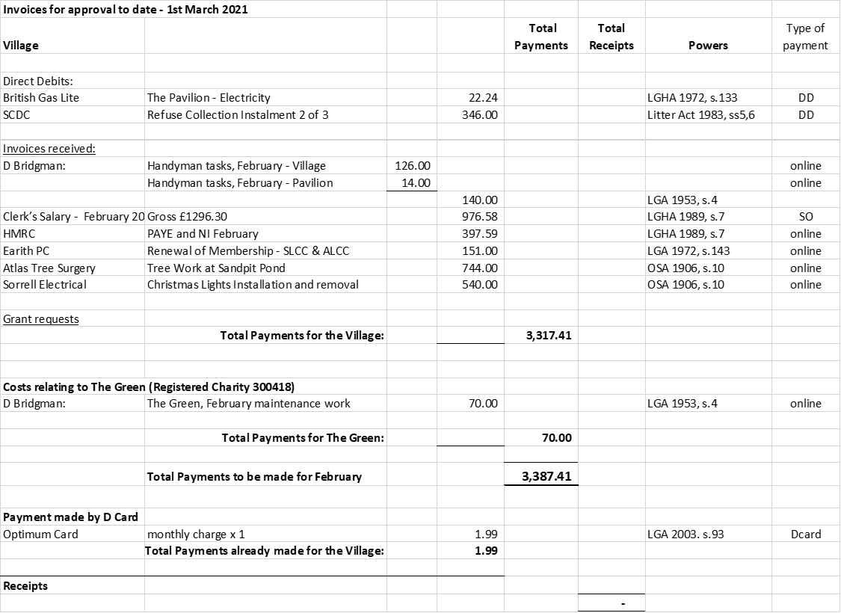

Next meeting dates: Full Council E-Meeting – 7.30pm Tuesday 13th April 2021
There being no further business, the meeting was declared closed at 10.23PM
Signed & dated Chairman.

