1341
Over Parish Council
7.30pm Minutes Full Council Informal E-Meeting – Tuesday 11th May 2021

This meeting of the Parish Council is an informal meeting and as such any decisions made at this meeting will be made now, in principle, and will be ratified at the next formal meeting.

PRESENT
Chairman: Mrs A Griffiths
Vice Chairman: Mr G Twiss
Councillors: Mrs J Davies, Mr S Couper, Mr M Conlon, Mr R Robinson
(3 Vacancies)
Parish Clerk: Mrs M Pink
In attendance
District Councillor: Mr B Handley
County Councillor: Ms Firouz Thompson
Parishioners: 0

The Current Chairman opens the meeting and welcomes the Councillors, members of the public and invites nominations for the New Chairman
Item
2021/05-01 Election of Chairman – Cllr Anne Griffiths nominated as Chairman by Cllr Steve Couper
The vote takes place
Cllr Steve Couper proposed, Seconded by Cllr Robert Robinson RESOLVED – All in Favour

The new Chairman takes the Chair and signs their declaration of office form

2021/05-02 To Receive and Accept Apologies for Absence
Mr A Tranter, Mrs M Hyde, District Cllr D Percival

2021/05-03 Election of Vice Chairman – Cllr Geoff Twiss nominated to remain as Vice Chairman by Cllr Anne Griffiths
The vote takes place
Cllr Anne Griffiths proposed, Seconded by Cllr Judith Davies. RESOLVED – All in Favour
2021/05-04 Members’ Declarations of Interest & Dispensations
4.1 Declarations of interest from councillors on items on the agenda – Registered Interests received from
Cllrs A Griffiths, R Robinson – Trustees of Over Relief in Need, and The Church and Town Lands Charity, Church and Town Branches
Cllr J Davies – Trustee of Over Community Association
4.2 Requests to Speak - No requests received to speak on any items as declared above.
4.3 To receive requests for dispensations - No requests received.
4.4 To grant requests received - The granting of dispensations to be made by Full Council.
2021/05-05 Matters of Interest from County and District Councillors and PCSO
5.1 County Council – Cllr Thompson thanked the Village for voting her into office and is looking forward to working with the Village of Over. Both she, and the Parish Council thanked retiring County Councillor Mr Peter Hudson for his support and work over the years. Cllr Thompson expressed a wish to work closely with the District Councillors and will work on combining Village reports if possible. It is hoped that the quarterly highways meetings will continue and that the County Council will look to re-prioritise budget to help with road issues.
5.2 District Council – Report noted – Cllr Handley reported that he would be happy to trial combining reports with the County for a few months. He reported that zero carbon community grants are now open and this could be a way of securing funding for the loft insulation in the Pavilion. He also wanted the Parish Council to note that the East West Northern rail route is still being discussed although the Southern route seems to be the most likely option at the moment.
5.3 Police – No report

1342

2021/05-06 Public Participation – No members of the Public present

2021/05-07 Minutes
7.1 To Approve Minutes of the Full Parish Council Meeting Dated 13th April 2021
RESOLVED: It was proposed, seconded, and unanimously agreed that the Minutes are approved
The Chairman will sign the Minutes at the next available Full Council Meeting. All actions have been completed. ACTION CHAIR
2021/05-08 Planning – For Discussion and Approval
Cllr Couper declared that he would not participate in the planning agenda item and would abstain from all decisions made
8.1 Application – 21/01079/OUT - Land Adjacent To 110 Station Road - Outline application for the erection of two dwellings with access from Station road, with all matters reserved
The Council discussed this item at length and agreed that the details given for the application were very scant and this did not allow the Council to fully understand the requirements. Without knowing the sizes of the two proposed dwellings the Council could not consider the parking aspect of this application as parking is already difficult in this area and two added dwellings could increase this problem. Therefore, the Parish Council will recommend that the District Council refuse this application as the build is outside of the Village development window and outside the framework of the Village on the West side of Station Road as this proposal is for land beyond the last home on this side of the road.
RESOLVED: It was proposed, seconded, and agreed five for with one abstention to recommend refusal as per the points noted above
8.2 Application – 21/01072/FUL - 23 Station Road - Erection of a dwelling with two new parking spaces for existing dwelling
RESOLVED: It was proposed, seconded, and agreed five for with one abstention that the Council comments are noted as no objections
8.3 Application – 21/00516/HFUL – 3 Meadow Lane – Erection of a single garage and attached store amendments to original application
RESOLVED: It was proposed, seconded, and agreed five for with one abstention that the Council comments are noted as no objections as the applicant has addressed the issues previously raised
Planning for Information Only
8.4 Application – 20/02477/CONDA – Land Off Fen End - Submission of details required by condition 3 (Materials), 7 (Surface Water Drainage Scheme), 8 (Surface Water Drainage Maintenance), 14 (Arboriculture Assessment), 16 (Traffic Management Plan), 17 (Footway Arrangement), 18 (Proposed Access Drainage), 19 (Maintenance of Streets) 21 (Construction Environment Management Plan) and 24 (Electric Vehicle Charging Plan) of planning permission 20/02477/FUL

Application for Site access amendments to 20/05343/FUL - 1 Drings Close (Doctors Surgery) was discussed by the Council although it was not placed on the Agenda by the Clerk as she had previously emailed this amendment to the Council asking if any comments were needed and received no feedback from the Councillors. The Council did not think that the disabled parking places had been placed in an accessible position and that the electric charging spaces could be moved to a less prominent position as vehicles would be occupying these spaces for a longer period of time and thus taking up valuable space for disabled users. Cllr Davies wanted to have clarification regarding the current access as it was not clear what would be happening in this area. Would there still be walk through access to the Surgery from Drings Close? The Council asked the Clerk to make these comments known to the Planning Department.
2021/05-09 Finance
9.1 Approval of Payments
RESOLVED: To approve invoices and payments to the sum of £23,626.31
The Clerk also asked the Council to authorise payments to Mr Wookey for carpentry works at the Pavilion and for Sorrell Electrical for lighting changes at the Pavilion. The payments are to be made now and then listed as payments on the May payment list. The Council agreed that the payments could be made.
1343
9.2 Receipts noted: £42,500 precept
9.3 OPC Accounts qrt 4 to be noted – Noted by Council
2021/05-10 Procedure Information & Approval
10.1 Annual Financial Risk Assessment to be noted – Noted by Council
10.2 Annual Return Acceptance of guidance section 1 – Agreed by Council
RESOLVED: It was proposed, seconded, and unanimously approved that AGAR Section 1 is agreed. The Clerk and Chairman are to sign the AGAR. ACTION CLERK & CHAIR
10.3 Annual Return Acceptance of section 2 – Agreed by Council
RESOLVED: It was proposed, seconded, and unanimously approved that AGAR Section 2 is agreed. The Clerk and Chairman are to sign the AGAR. ACTION CLERK & CHAIR
10.4 Standing Orders to be noted – No changes to be made
10.5 Financial Regulations to be noted – As of January 2021 the UK withdrawal from the EU was finalised and the UK joined the World Trade Organisation General Procurement Agreement and recognise the current thresholds as being equivalent to the EU Directives (F Regs 13.3) ACTION CLERK
10.6 Parish Councillor Responsibilities and Representative status to be agreed – The Council agreed to keep all Responsibilities as per last year. The Clerk is to add on Responsibilities for Community Warden Liaison as the Clerk and Cllr Hyde and Speedwatch as Cllr Conlon. Cllr Davies is to remain as a back up to help with grants if needed. ACTION CLERK
10.7 Code of Conduct – The LGA agreed a new code of conduct in December 2020 and NALC agreed a new code of conduct in April 2021 but confirmation of changes has not yet been provided by CAPALC. I will be attending a training course in May to see what these changes are and will have this as an agenda item in June for consideration – Noted by Council
2021/05-11 Village Matters Information & Approval
11.1 Asplins Close parking area update – No new update
11.2 Protection of Overcote from Illegal Encampments update – The Clerk has completed the online training and links have been sent to the Chairman and Cllr Hyde. Toolkit to be released on the 1st June
11.3 Pavilion – Quotes for loft insulation to be considered – Cllr Robinson had obtained three quotes for the proposed loft insulation. One Contractor did not have the relevant Public Liability Insurance so the quote was not considered. Two other quotes were put forward for the Council to consider.
Quote 1 for £658.35 plus VAT
Quote 2 for £1887.00 plus VAT
RESOLVED: It was proposed, seconded, and unanimously agreed that quote 1 is accepted. The Clerk will issue a purchase order and work will be completed following the CCTV installation already actioned for the Pavilion. ACTION CLERK
11.4 Tree maintenance needed at Parish Council land adjacent to 7 Station Road – The Council discussed this item and agreed that pollarding of both trees in this area should be carried out. The Clerk is to contact Atlas Tree Surgery and ask them to liaise with Cllr Robinson who is to be the lead Councillor for this project. ACTION CLERK
11.5 RBL proposal for new bench at the Memorial site at Long Furlong – The Council discussed this item and agreed that the proposed bench could be sited at the Memorial site.
RESOLVED: It was proposed, seconded, and unanimously agreed as above ACTION CLERK
2021/05-12 Village Reports
12.1 To receive Village Handyman Report and consider any maintenance items – No report
12.2 To receive Groundsman Report re the Green – No report
2021/05-13 PC representatives on Village Charities and other bodies – Matters of interest Information
13.1 Hanson Aggregates – No report
13.2 Over Relief in Need, and The Church and Town Lands Charity, Church and Town Branches – No report next meeting on the 17th May
13.3 Over Community Association – Cllr Davies reported that a short meeting was held that confirmed that grants had been approved and that the Vaccination programme will soon be moving to larger sites to finish the final phase of vaccinations for the county.
13.4 Over Day Centre – Cllr Couper reported that the Centre opened in April with a reduced client base but this will increase in time when they open for longer. Volunteers are still working on the SCDC Meals Scheme
13.5 Community Warden – No report
1344

13.6 Speed Watch – Cllr Conlon reported that sessions are now able to restart as of the 17th May and he is checking to see if the team are happy to carry on.
2021/05-14 Correspondence received – None

Cllr Couper asked the Clerk if a new Councillor Vacancy notice is to be included in the next Over News.

The Council considered the question of holding a meeting in June. The Seminar room is too small and some Councillors and the Clerk did not feel able to return to face-to-face meetings at the moment. The main Hall at the Centre is to be looked into for a meeting in July.

Cllr Davies has cleaned the bench at the Church and Cllr Robinson thanked her on behalf of the Robinson family.

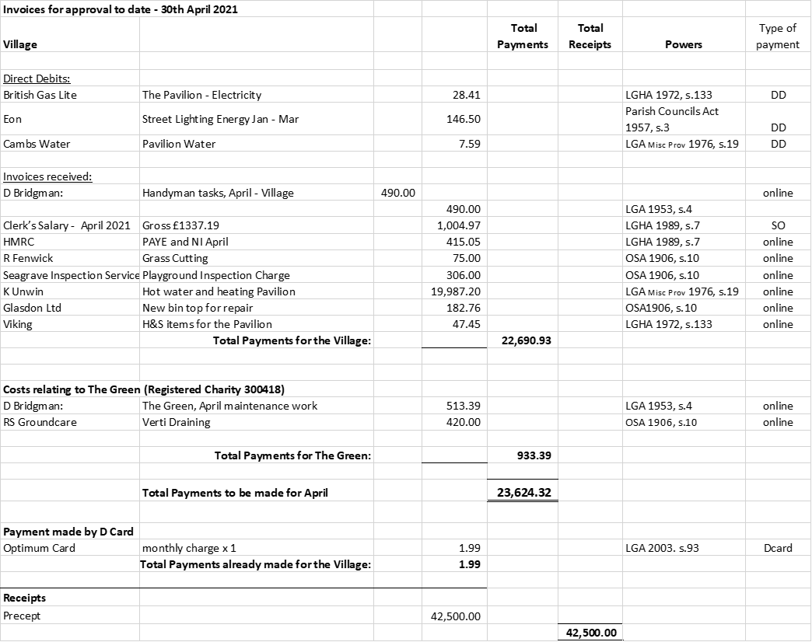

Next meeting dates: Full Council Informal E-Meeting – 7.30pm Tuesday 8th June 2021
There being no further business, the meeting was declared closed at 9.17PM
Signed & dated Chairman.

