1364
Over Parish Council
7.30pm Minutes Co-Option Meeting – Tuesday 12th October 2021
PRESENT
Chairman: Mrs A Griffiths
Vice Chairman: Mr G Twiss
Councillors: Mrs J Davies, Mrs M Hyde, Mr R Robinson, Mr A Tranter, Mr M Conlon
(3 Vacancies)
Parish Clerk: Mrs M Pink
In attendance
County Councillor: Cllr Firouz Thompson
District Councillor: Cllr Bill Handley
Parishioners: 1

Item
2021/10-01 To Receive and Accept Apologies for Absence
Mr S Couper, District Cllr D Percival

2021/10-02 Co-option of Councillor to fill One vacancy (two further vacancies due to resignation)
The Clerk has received an application from Mr Michael Grange to cover one vacancy for a Councillor on Over Parish Council. The application was circulated prior to the Meeting.

The Vote takes place

Resolved: It was proposed, seconded and unanimously approved that the applicant is asked to become a member of the Council.
The Clerk asked Mr M Grange to complete the acceptance of office form.

The Chairman thanked Mr Grange and welcomed him to the Council and asked him to take a place at the Council table at the Full Council meeting which is now convened.

Over Parish Council
7.35pm Minutes Full Council Meeting – Tuesday 12th October 2021
PRESENT
Chairman: Mrs A Griffiths
Vice Chairman: Mr G Twiss
Councillors: Mrs J Davies, Mrs M Hyde, Mr R Robinson, Mr A Tranter, Mr M Conlon, Mr M Grange (2 Vacancies)
Parish Clerk: Mrs M Pink
In attendance
County Councillor: Cllr Firouz Thompson
District Councillor: Cllr Bill Handley
Parishioners: 0

2021/10-01 To Receive and Accept Apologies for Absence
Mr S Couper, District Cllr D Percival
2021/10-02 Members’ Declarations of Interest & Dispensations
2.1 Declarations of interest from councillors on items on the agenda – Registered Interests received from
Cllr A Tranter – Trustee of Over Day Centre
Cllr R Robinson, Mrs M Hyde – Trustees of Over Relief in Need, and The Church and Town Lands Charity, Estate and Town Branches
Cllr J Davies – Trustee of Over Community Association
2.2 Requests to Speak - No requests received to speak on any items as declared above.
2.3 To receive requests for dispensations - No requests received.
2.4 To grant requests received - The granting of dispensations to be made by Full Council.
2021/10-03 Matters of Interest from County and District Councillors and PCSO
3.1 County Council – Cllr Thompson reported that West Street flooding works have been scheduled for Thursday. Emailed report noted by Council. Mrs J Davies asked if the speed limit could be changed at the School to a 20mph area along Long Furlong. The School Governors are concerned about the
1365
vehicle speeds on this stretch of road despite the new road markings that are now clearly shown on the Road. Cllr Thompson recommended that the Parish Council put in an LHI Bid next year to see if this change of speed limit can be actioned and asked Mrs Davies to forward the email from the Governors so that it can be formerly noted. ACTION JD
3.2 District Council – Emailed report noted by Council
3.3 Police – No report

2021/10-04 Public Participation – No comments

2021/10-05 Minutes
5.1 To Approve Minutes of the Full Parish Council Meeting Dated 14th September 2021.
RESOLVED: It was proposed, seconded, and unanimously agreed that the Minutes are approved. Chairman to sign the Minutes. ACTION CHAIR
Mr Twiss noted that the Annual Parish Meeting Draft Minutes should be presented to the Council so that any actions can be taken up and the Chairman asked the Clerk to add this to the Agenda in November. ACTION CLERK

2021/10-06 Planning for Discussion and Comments
6.1 Application – 21/04077/ADV - Land at Junction of Mill Road and Willingham Road – Installation of 2 no. post mounted signs and 6 no flags
RESOLVED: It was proposed, seconded, and unanimously agreed that the Council comments are noted as no objections.
6.2 Application – 21/04287/HFUL - 37-39 Fen End – Conversion of existing garage and new link to existing dwelling
RESOLVED: It was proposed, seconded, and unanimously agreed that the Council comments are noted as no objections
6.3 Application – 21/04288/LBC - 37-39 Fen End – Conversion of existing garage and new link to existing dwelling
RESOLVED: It was proposed, seconded, and unanimously agreed that the Council comments are noted as no objections

Planning for Information Only or Comments if needed
6.4 Application – S/4201/18/CONDA – Land East of 7 Longstanton Road – Submission of details required by condition 3 (Materials) of planning permission S/4201/18/VC – Noted by Council
6.5 Application – 21/1182/TTCA – 2 Horse Ware – S211 tree works notice (Conservation area) – Noted by Council
6.6 Application – 21/1207/TTCA – 20 High Street – S211 tree works notice (Conservation area) – Noted by Council
6.7 Application – S/2442/19/FL – The Piggery, Haden Way – Amendment extended red line boundary to connect Highway and Certificate D served. – Noted to defer comments to Willingham PC
Mr Twiss noted that the Appeal hearing for 20/03254/OUT - 30-32 New Road is due on the 16th November 2021 and he asked the Clerk to automatically book him a space at the Appeal.
2021/10-07 Finance
7.1 Approval of Payments – £6,367.37
RESOLVED: To approve invoices and payments to the sum of £6,367.37.
7.2 Receipts noted: £42,500 Precept
7.3 RBL Donation towards the cost of wreath to be discussed
RESOLVED: It was proposed, seconded, and unanimously agreed that the Council provide a donation of £50 to cover the cost of the wreath and a donation to the RBL Branch. Mr M Conlon to lay the wreath
7.4 Resident request asking for support in raising funds for repairs to Over Windmill – The Clerk had received an email from a resident asking for support with fund raising to help with repairs to the Windmill. The Windmill is a privately owned business and as such direct funds from the Council cannot be given, as any funding provided by the Council must benefit the residents of the Village and not just one party. However, the Council will look into possibly having the building listed as a Community Asset and DC Cllr Handley will look into this in more detail. The Clerk is to offer information regarding other grant funding streams that the business owner can consider such as
1366
English Heritage. The Windmill is a historic Village landmark and must be conserved as such for posterity. A Community Champion or Group should be encouraged to take this project on to allow for fund raising and maintenance work to be completed. The Clerk, in conjunction with the Chairman, will contact the owner to give them the information provided by the Council. ACTION CLERK & CHAIR

Parish Council meeting suspended in order to discuss items relating to the Registered Charity for The Green (Charity number: 300418) Parish Council is Sole Trustee of the Charity
2021/10-08 The Green as a Charity
8.1 Grass Cutting Contract to be agreed for the new season in 2022 – The Clerk had provided the Councillors with information concerning three quotations that she had received.
Option 1 - £50 per cut at green no clippings collected based on 16 cuts
Option 2 - £75 per cut at green no clippings collected based on 16 cuts
Option 3 - £49.25 per cut at green no clippings collected based on 16 cuts
The options quoted also provided costs for grass cutting at the Centre which are additional to the costs stated above.
RESOLVED: It was proposed, seconded, and unanimously agreed that Option 1 should be accepted.

The Council also considered other potential land areas that could accommodate a sports activity within the Village and two areas in particular have been highlighted that belong to the County Council and can possibly be leased in the interim until other options can be provided. Over Village is under provided for public open green space and this was questioned at length during the Annual Parish Meeting. The Parish Council have therefore been looking to explore other options available for the provision of Public Open Space for the recreational use of the whole Village. It was agreed that two action groups would be established to look into strategic sources of new land for recreational sports and activity and to look into what the Village users would actually want to see in the Village. Sporting facilities are not paramount in all Villagers thinking and recreational usage by all residents will also be contemplated. With these two different action streams identified the Council agreed that:-
- Mr Twiss and Mr Grange would look to open up a dialogue with the Village Sports facilities
- Mrs Davies would look to open up a dialogue with other green open space users as it is not just sports facilities that need to be provided in the Village.
Mr Grange also noted that more teenage open space priorities should be considered such as open-air exercise equipment available for all.
This will be an Agenda item for further updates in November. ACTION GT, MG, JD & CLERK

Mrs Hyde also clarified some action points needed by the Community Groups responsible for the Christmas Lights. Tree base barriers, sponsorship banners and lighting options where queried and solutions given. The Clerk is to provide Mrs Hyde with the electrician’s details. ACTION MH & CLERK

Parish Council meeting reconvened

2021/10-09 Procedure
9.1 External Audit report to be noted – Noted by Council – Thanks were given to the Clerk.
9.2 Standardised Council email addresses to be discussed – The Clerk had provided some further information and costings and Mr Grange will look into this in more detail as he has experience of this matter and will report back in November. ACTION MG
9.3 Local Government (Miscellaneous Provisions) Act 1982 – Street Trading to be noted – Public Notice of proposed resolution to re-designate streets within South Cambridgeshire District as Consent Streets – Noted by Council.
9.4 OxCam Arc spatial framework consultation to be discussed – Noted by Council as no comments to make. This is a Nationwide Consultation and although it will add to the road network system it will also encourage more homes to be built which could damage the environment.
9.5 Street naming for 26 New Dwellings at Site Adjacent Longstanton Road – one favourite and two fall backs to be considered – The Council nominated the name of Sandpit Close and as this was favoured by most it was agreed that this name should be put forward. ACTION CLERK

2021/10-10 Village Matters
10.1 Asplins Close parking area update – The Clerk is to get some quotations for the work needed and will organise a letter drop to alert the residents of Asplins Close to the proposed changes to the grassed area and to assess the need for parking. ACTION CLERK
1367
10.2 Illegal Encampments update – No new information
10.3 Countryside Stewardship to be discussed – The Clerk and Village Maintenance Contractor would very much like to explore the many grants offered by Natural England under the Countryside Stewardship Programme as highlighted to the Clerk by the County Council Rights of Way Officer. Many different pots of money can be applied for. Hedge gapping, tree surgery and other hedge and tree work grants could be available. The Clerk asked the Council to support her in trying to find some new grant funding for Village Maintenance issues. The trees in the Doles, for instance, are owned by various different organisations but if grants can be sourced for all then more work can be carried out on all trees and not just those owned by the Parish Council. The Chairman asked the Clerk to report a fallen tree on the Ouse Fen Bank about a third of the way down from Overcote Road end. This footpath is the responsibility of the County Council, and the Clerk will report this using the online reporting tool offered by the County Council. ACTION CLERK
RESOLVED: It was proposed, seconded, and unanimously agreed that the Clerk can look into this funding programme in more depth to help with Village Maintenance.
10.4 Request from the 20’s Plenty Campaign for the Council to support the normalisation of 20mph in the Village of Over – Further to the Annual Parish Meeting presentation the Council agreed to support normalisation of a 20mph in Villages.
RESOLVED: It was proposed, seconded, and unanimously agreed that support should be given to the 20’s plenty campaign to normalise 20mph in Villages within the County.
10.5 Climate Change – Plastic Free Communities scheme to be discussed – Further to the Annual Parish Meeting presentation on Climate Change the Clerk has been looking into ways in which the Council can make a difference and the Plastic Free Communities Initiative can be a good way of making a start. A Community Group may be needed to carry out all of the steps in the plan to become plastic free accredited and the Clerk will try to move this forward. Mrs Hyde will invite the Clerk to become a member of the Over Eco Facebook group to see if this is an initiative that the Village would like to work towards. ACTION CLERK & MH
10.6 Tree maintenance at Websters Way to be discussed – Mr Robinson had been contacted via email concerning some overhanging trees in Websters Way. He had given the Clerk a quote to cut back the branches and the Clerk tabled this for agreement.
RESOLVED: It was proposed, seconded, and unanimously agreed that the Clerk can organise for the work to be carried out to the trees in Websters Way. ACTION CLERK
10.7 Official PC thank you to be given to the Overcote slipway cleaning team to be noted – Noted by Council and acknowledged in these Minutes. Thank you to the Overcote Slipway cleaning team.

2021/10-10 Village Reports
10.1 To receive Village Handyman Report – Noted by Council
10.2 To receive Village Maintenance Report – Noted by Council
Mrs Davies reported that she would like to see some maintenance carried out at the small children’s play area at the Centre. Some painting of the wooden items and some strimming and cutting of the grass. Both Mrs Davies and Mrs Hyde thought that the area looked uncared for. Mrs Davies will walk around the area and give the Clerk some points to look at. Mr Twiss also asked the Clerk to look into some more maintenance at Sandpit Pond. Both of these areas should be included in a regular maintenance schedule that the Clerk can work out and administer with the help of the Village Maintenance Contractor. ACTION CLERK & JD

2021/10-12 PC representatives on Village Charities and other bodies – Matters of interest
12.1 Hanson Aggregates – Cllr Robinson reported that there had not been any meetings
12.2 Over Relief in Need, and The Church and Town Lands Charity, Estate and Town Branches – Cllr Robinson reported that a lease is being organised for the use of the Hall. The Clerk had also received a email asking for a new Nominative Trustee following the resignation of Mr Tim Henshaw. The Council asked the Clerk to write to Mr Henshaw to thank him for his valuable work as a Nominative Trustee.
RESOLVED: It was proposed, seconded, and unanimously agreed that Mr Graham Fenn should be approached to see if he would like to act as a Nominative Trustee for the Charities listed above. The Nominee did not have to be a Councillor. The Clerk is to approach Mr Fenn and then report back to the Charity if he is happy to accept the Nomination. ACTION CLERK
1368
12.3 Over Community Association – The Chairman reported that OCA had requested a report on the funds available for OCA Projects and the Clerk had provided a report on the funds currently available in the Council reserve fund and Cllr Tranter had given a report regarding the monies negotiated in the S106 agreements that the Council had manged to agree. Trading levels are back up to pre covid days and it is hoped that new projects can be prioritised and organised to help the Centre to flourish within the Community.
12.4 Over Day Centre – Cllr Tranter reported that the Centre is currently open for 4 days per week, moving to five days in December. The emphasis now is to attract more clients.
12.5 Community Warden – The Clerk had a meeting with the warden and the level of provision currently sits at 2 clients in Over and four in Willingham and is not as high as expected. More awareness is needed to move the project forwards. The Age UK Representative will attend the PC meeting in November to give a more detailed report.
12.6 Speed Watch – Cllr Conlon thanked Cllr Robinson for his help with maintenance to the batteries. There will be approximately two more sessions until the end of the year and will resume again early in the New Year. Only one new volunteer has replied to the appeal for help.

2021/10-13 Correspondence received – None
Cllr Robinson reported that he had received a phone call from a resident who was concerned about late night noise from the Pike and Eel during a wedding reception in the Marquee. The resident should contact the licensing department to report this issue so that the problem can be passed back to the Owners for action. As yet the Clerk has not been contacted about this but will respond as proposed above if a complaint is received. The resident told Cllr Robinson that they had contacted the Clerk but she has not received any correspondence about this issue.

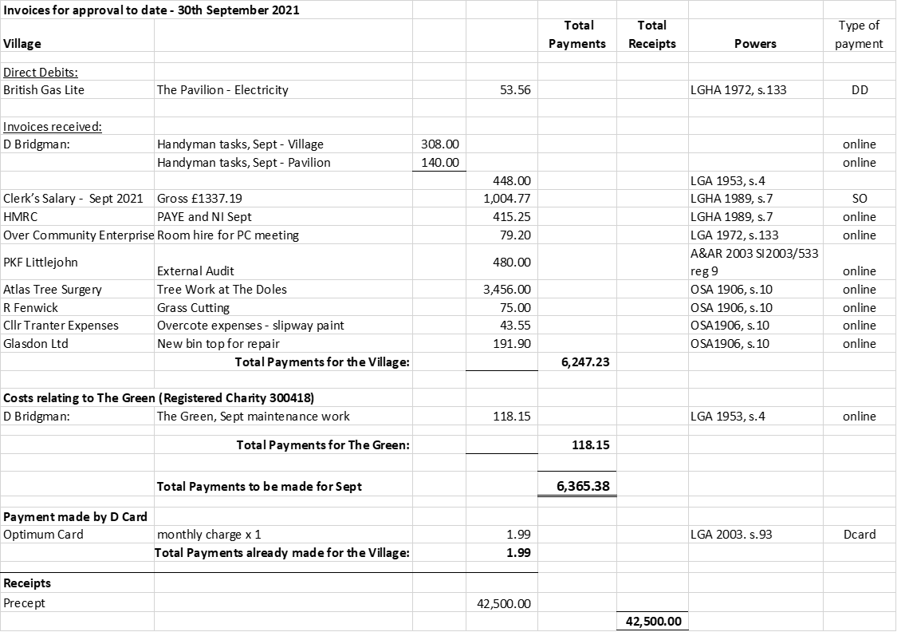
Next meeting dates: Full Council Meeting – 7.30pm Tuesday 9th November 2021
There being no further business, the meeting was declared closed at 9.55PM
Signed & dated Chairman.

