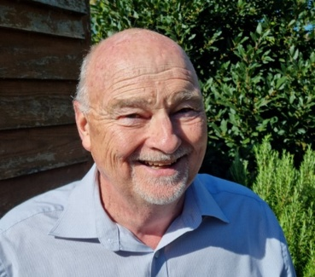

South Cambs District Council (SCDC) Councillor Bill Handley’s Report to Over Parish Council
– April 2026

SCDC wins funding for AI ‘proof of concept’ projects

SCDC has successfully secured funding for collaborative work with the University of Cambridge to explore how artificial intelligence (AI) can support councils to improve services and make more effective use of data. The 12 month project is to deliver a proof of concept in five areas:

- Predictive risk intelligence for social housing maintenance (PRISM).
- Human orientated AI – a design framework for reaching vulnerable tenants (housing).
- Map automation for planning and local efficiency (MAPLE).
- AI Enabled surveys (planning)
- Automatic fly-tipping detection using refuse collection vehicle cameras.

More information can be found here: AI@Cam Local Government AI Accelerator programme.

Zero Carbon Communities (ZCC) Scheme

SCDC has committed another £152,000 to the popular ZCC grant scheme. The amount that applicants can apply for has risen from £15,000 per project to £19,500. Since the scheme was launched in 2019, it has supported 82 different projects, awarding over £855,000 to initiatives across the district including energy generation and efficiency, conservation measures at community buildings, community cycling events, cycle shelters, food waste reduction initiatives, community allotment and gardening projects.

The application window will open on Monday 25 May and close on Friday 24 July 2026. Projects on school sites and by parent / teacher associations will be able to apply – if there is a benefit to the wider community. Those interested in applying for a Zero Carbon Communities grant can join a workshop to find out more. Two sessions are to be held on Wednesday 20 May - one running from 12:30pm to 1:30pm and a second one from 6pm to 7pm. Potential applicants are encouraged to register for either.

The Unity Centre, Northstowe

Last week SCDC and builder Kier Construction celebrated the completion of the Unity Centre – the permanent community centre in Northstowe. This is a key milestone in Northstowe’s Phase 1 development and a significant achievement for the Council, setting the highest possible standards for new community facilities. Northstowe Town Council now have the keys, having taken over the lease, and the doors are due to open to the public from 30 March. The building has been constructed to combine Passive House principles (low operational carbon) with low lifecycle carbon materials to deliver a net zero design. Built entirely from timber, the building combines Cross Laminated Timber panels with Glulam beams – a super-structural frame. The exterior is cladded with Shou Sugi Ban timber and zinc – both low carbon and low maintenance. It is heated by a Ground Source Heat Pump – making the most of the enclosed garden space to power the building using renewable energy. The centre’s distinctive roof is designed to maximise space for solar panels and also hosts a green roof. Similarly, the pergola that wraps the building is covered by a green sedum roof to maximise the opportunity for biodiversity.

Cancellation of non-responding postal votes

SCDC officers and councillors have, for several months, been campaigning to warn residents of the expiry of postal votes, which is a legal requirement and happens every three years. The deadline to apply for an extension has now passed and the postal votes of 4,266 residents have had to be cancelled (of the original 15,392 that required renewal) which represents a 72.28% positive response rate. All affected voters will receive a letter to inform them of this change and will also include details on how they might make a new application to vote by post if they wish. Applications need to be received by 5pm on 21 April 2026 to get a postal vote for the 7 May 2026 elections.

If you have any questions, please email elections@scambs.gov.uk.

Local authority pre-election period begins on Monday 30th March

The pre-election period for local authority elections starts on Monday 30th March and runs until the close of polls on Thursday 7th May. This should not unduly affect the PC.

Bill

Bill Handley

District Councillor for Over and Willingham
Phone: 01954 200287 (leave a message). Email: cllr.handley@scambs.gov.uk

