OVER VILLAGE PRODUCE SHOW 2026
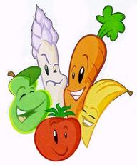
Saturday 1st August 2.00 – 4.30pm in Over Community Centre Main Hall
Calling all Over residents to make a note of this date in your diary. Why not make this the first time you enter one or more of the categories?
We have all the usual Produce classes: Vegetables, Fruit, Plants, Flowers & Arrangements, Home Cooking, Jams and Preserves, Homemade Beers and Spirits. The three subjects for both the Adult and Children’s Photography classes this year are Blue, Boats and Blooms. Hopefully this should give lots of scope for creative photography when you are out and about with your camera or mobile phone. After the success of our first Craft Section last year we will be making this a permanent section in the show so keep crafting. We have also added two new categories: 1 sewn item and 1 item of wickerwork.
The Children’s Section incudes Home Baking, Collage, Decorated Egg, Garden on a Baking Tray and Photography. Please encourage your youngsters to take part.
More details of the full Schedule of classes to follow shortly.
Cynthia Bidwell – OVPS Committee Member

